**TALLER 4**

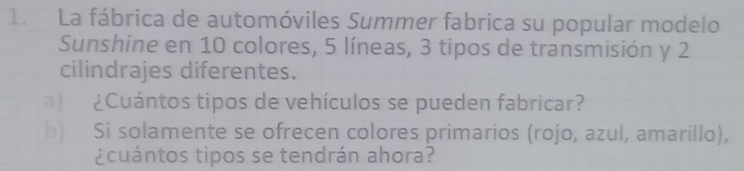

1. 10 x 5 x 3 x 2 = 300
2. 3 x 5 x 3 x 2 = 90



1. 26 x 26 x 26 x 10 x 10 x 10 = 17576000
2. 26 x 25 x 24 x 10 x 9 x 8 = 11232000



1. 1 x 1 x 2^12 x 1 x 1 = 4096



1. P(12,4) = $12!/8!$ = 11880



1. 9! = 362880
2. paso1(Latín) = 5! = 120

paso2(Todos) = 5! = 120

rta = 120 x 120 = 14400

1. 5! x 4! = 120 x 24 = 2880